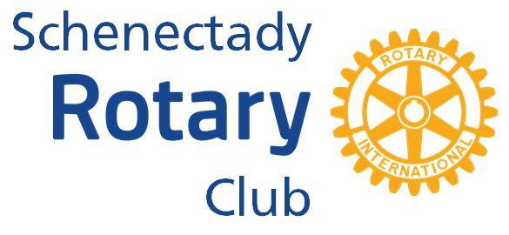

The Rotary Club of Schenectady Foundation, Inc.
Requests for Funding Proposals for 2022

Complete this application using no more than two pages.
Date:
Name of Organization:
Name of Contact:
Address:
Phone Number:
Email Address:
REQUEST
Amount Requested:
Amount requested cannot exceed $1,000. The Foundation reserve the right to award funds that may differ from amount requested.
PROJECT
1. Describe the program and the specific community needs it addresses. (ie. the community as a whole, youth in the community)
2. How does the project support the mission of the organization?
3. How many clients/community members does the program serve?
4. What is the total cost of the project?
5. Is there an opportunity for Rotary members to be engaged in the project in addition to awarding monetary funds? (ie. volunteering, mentoring, coaching)
6. How can Rotary receive recognition for our support of this project?
7. When did your organization last apply for funding? What was the project and was your request granted?
8. If your project has a deadline please include that date in your application.
Mal Application to: Schenectady Rotary Club Foundation, Inc.
PO Box 346, Schenectady, New York 12301. Attention: Amy Brule

